[**‘Law & Order: Organized Crime’ Boss on a Season 3 Reset for Stabler & Crew**](https://www.tvinsider.com/1058748/law-order-organized-crime-season-3-christopher-meloni-stabler-new-characters/)

[***Ileane Rudolph***](https://www.tvinsider.com/author/ileane-rudolph/)

[Chefe de ‘Law & Order: Organized Crime’ com um reset da 3ª temporada para Stabler e equipe](https://www.tvinsider.com/1058748/law-order-organized-crime-season-3-christopher-meloni-stabler-new-characters/)

[***Ileane Rudolph***](https://www.tvinsider.com/author/ileane-rudolph/)

SEPTEMBER 22

FALL PREVIE

Will Hart/NBC

Hit the reset button! Season 3 of [***Law & Order: Organized Crime***](https://www.tvinsider.com/show/law-&-order-organized-crime/) does just that, says executive producer Bryan Goluboff, starting with new detectives in the Organized Crime squad.

Aperte o botão reset! Season 3 de [***Law & Order: Organized Crime***](https://www.tvinsider.com/show/law-&-order-organized-crime/)faz exatamente isso, disse o produtor executivo Goluboff, começando com novos detetives no esquadrão Organized Crime.

Bobby Reyes ([**Rick Gonzalez**](https://www.tvinsider.com/people/rick-gonzalez/), [***Arrow***](https://www.tvinsider.com/show/arrow/)) is a versatile undercover expert, and Jamie Whelan (Brent Antonello, [***Pam & Tommy***](https://www.tvinsider.com/show/pam-and-tommy/)) idolizes Stabler ([**Christopher Meloni**](https://www.tvinsider.com/people/christopher-meloni/)) for his riskiest qualities — exactly the behaviors he wants to change as he undertakes, along with Sgt. Ayanna Bell ([**Danielle Moné Truitt**](https://www.tvinsider.com/people/danielle-mone-truitt/)), a personal evolution.

Bobby Reyes ([**Rick Gonzalez**](https://www.tvinsider.com/people/rick-gonzalez/), [***Arrow***](https://www.tvinsider.com/show/arrow/)) é um versátil especialista disfarçado, e Jamie Whelan (Brent Antonello, [***Pam & Tommy***](https://www.tvinsider.com/show/pam-and-tommy/)) idolatram Stabler ([**Christopher Meloni**](https://www.tvinsider.com/people/christopher-meloni/)) for suas qualidades de alto risco – exatamente os comportamentos que ele quer mudar enquanto ele se compromete, juntamente com Sgt. Ayanna Bell ([**Danielle Moné Truitt**](https://www.tvinsider.com/people/danielle-mone-truitt/)), uma evolução pessoal.

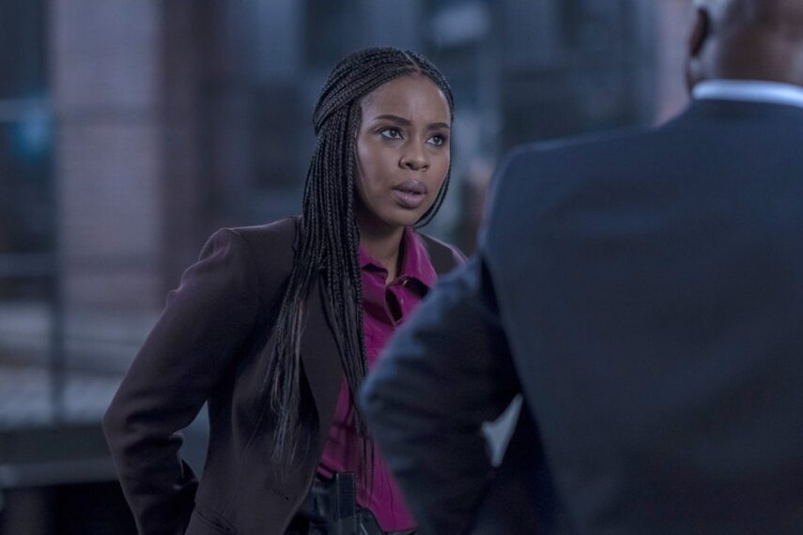

(Credit: Zach Dilgard/NBC)

The two empty nesters are asking themselves, “Who am I?” in terms of their costly total devotion to the job, the EP notes.

Os dois ninhos vazios estão se perguntando, “Quem sou eu?” em termos de sua devoção grandiosa total ao trabalho, os PE observam.

The answer: damn fine cops who accept that if their lives *are* singularly about law enforcement, it’s “‘Let’s be the best we can possibly be,’” he adds. “That’s bad news for the bad guys.”

A resposta: policiais muito bons que aceitam que se suas vidas são singularmente sobre aplicação da lei, é “vamos ser o melhor que nós possivelmente podemos ser,” ele adiciona. “Que é a má notícia para os bandidos.”

Those would be the mobbed-up folks building a new NYC casino. On the unit’s radar: pretty power couple Pearl Serrano ([**Camilla Belle**](https://www.tvinsider.com/people/camilla-belle/)) and Teddy Silas ([**Gus Halper**](https://www.tvinsider.com/people/gus-halper/), [***Fear the Walking Dead***](https://www.tvinsider.com/show/fear-the-walking-dead/)).

Essas seriam as pessoas assediadas construindo um novo cassino em NYC. No radar da Unidade: Pearl Serrano ([**Camilla Belle**](https://www.tvinsider.com/people/camilla-belle/)) e Teddy Silas ([**Gus Halper**](https://www.tvinsider.com/people/gus-halper/), [***Fear the Walking Dead***](https://www.tvinsider.com/show/fear-the-walking-dead/)), um bonito poderoso casal.

***Law & Order: Organized Crime*, Season 3 Premiere, Thursday, September 22, 8/7c, NBC; starting September 29, 10/9c.**

***Law & Order: Organized Crime*, Premiere Temporada 3, Quinta-feira, 22 de setembro. 8/7c, NBC; começando 29 de setembro, 10/9c.**